Celebrating CTPA’s 81st Year!!!
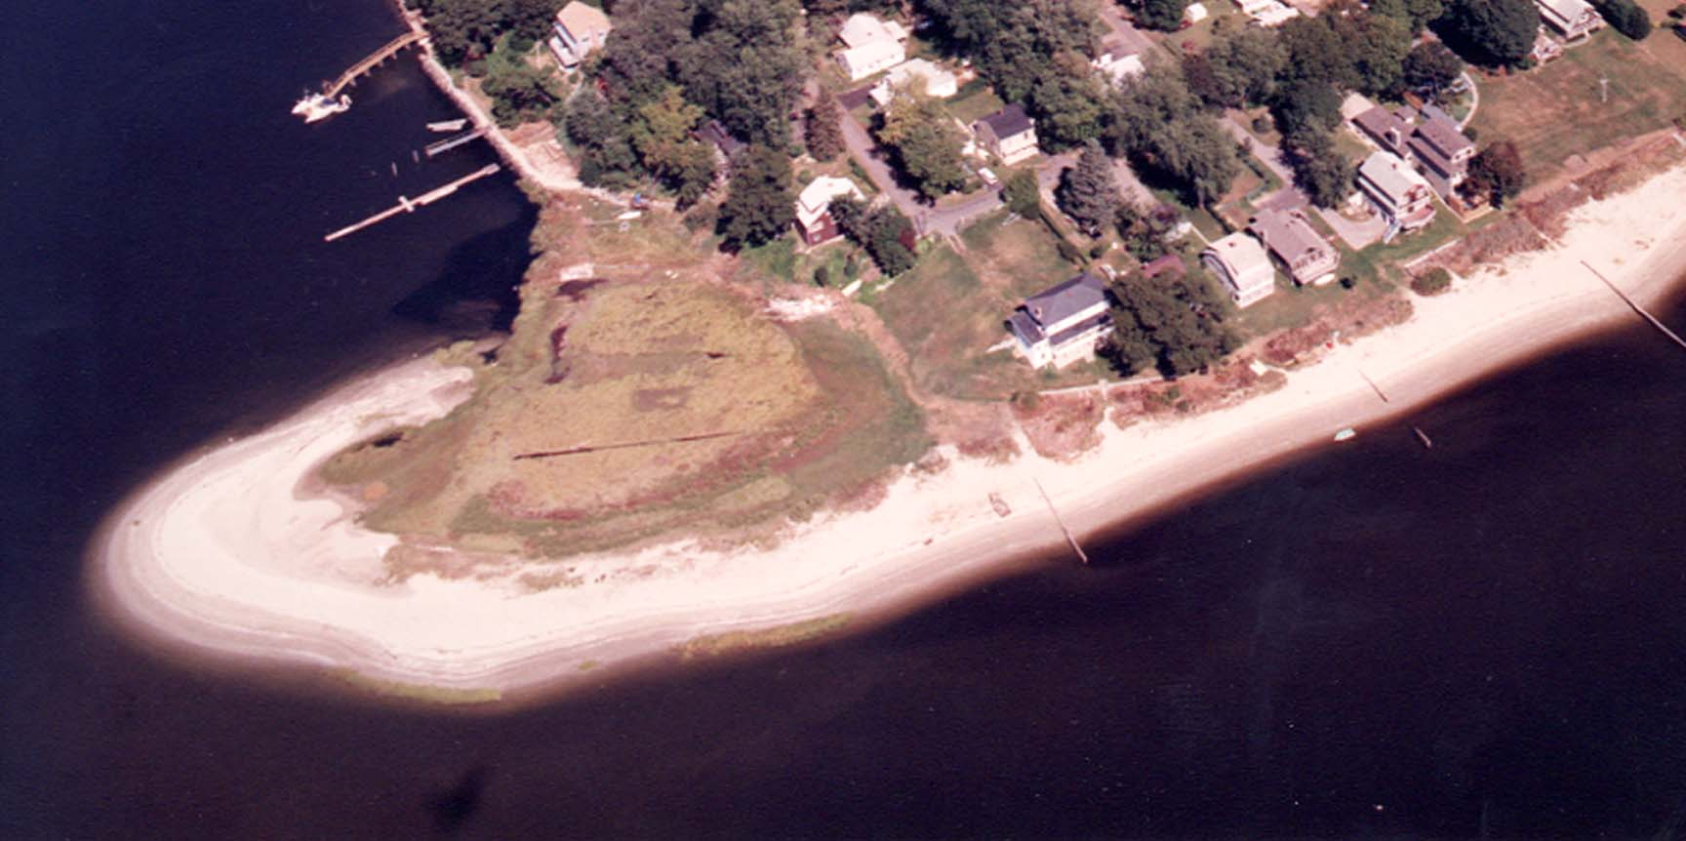
Cedar Tree Point Association – Founded 1924 - Visit our website: www.cedartreepoint.org
Welcome to Cedar Tree Point Association's Social Events Calendar for 2005! Everyone is welcome to join us in celebrating our community at these events. Last year was an exceptionally successful year for CTPA. All of the events were well attended with great fun and fellowship had by all! Our second annual Lobster & CLAM Bake was a GREAT success where 36 people enjoyed lobsters, steamers and all the fixings! Mark your calendars now and don’t miss these fun events! Please call Dave Pickering, President at 737-7769 or Mike Hoglund, Treasurer at 738-8488 if you have any questions!
Saturday CTPA’s Big Spring Event!
June 18th: Annual Beach Clean- Up: 8:30am – 11:00am: Join your friends for an early morning breakfast at 8:30 before the start of our annual beach clean-up from 9:00 AM - 11:00 AM! Location to be determined (TBD)
Yard Sale – 8:00am – 12:00pm: Clean out your cellars and garages! With spring cleaning on everyone’s mind, and at the request of many members, we will be conducting a CTPA Yard Sale! If you have any items you would like to donate to the CTPA, please bring any items to Dave & Leann Pickering’s at 110 Melbourne Road on Friday afternoon (6/18) anytime after 4:30pm, or by 8:30am Saturday morning. Please place a price on each item that you bring! Watch for a special flyer for more information!
Cookout! 6:00pm – 8:30pm Join your friends and neighbors for chicken, hamburgers or hotdogs along with all the fixings!
Campfire & S’Mores 8:30pm - ?!! Following the cookout, we will have one of our famous “Campfires on the Point”! Bring your lawn chair and join your friends for an evening around a warm campfire for fun and s’mores!

Saturday, Annual Steak Fry / Campfire One of CTPA’s favorite events!
July 30th: This years event will begin at 5:30. Location TBD.

Saturday, Annual CTPA Lobster Clam Bake The annual CTPA Lobster Bake August 20th: will be held again this year on the beach! Location TBD.

Saturday Fall Cookout and Barbecue! Don’t miss our annual fall cookout on the
Sept. 17th beach featuring summer picnic food, e.g., chicken/hot dogs/hamburgers and all the fixing’s. A campfire with s’mores & music will follow! Location TBD.

Friday, Annual CTPA Fall Meeting CTPA's semi-annual association meeting.
Oct. 21st: Location TBD. Starting time is 7:00 PM. Location TBD.

Special Note: CTPA annual membership dues have remained at $20 per family per year, for many, many years. The CTPA Board does this to insure that every family can afford to belong! Please contact Mike Hoglund, Treasurer at 401-738-8488 with any membership questions. You may mail your dues, payable to Cedar Tree Point Association, to Mike Hoglund, 22 Ferncliff Avenue, Warwick, RI 02886.

