Celebrating CTPA’s 82nd Year!!!
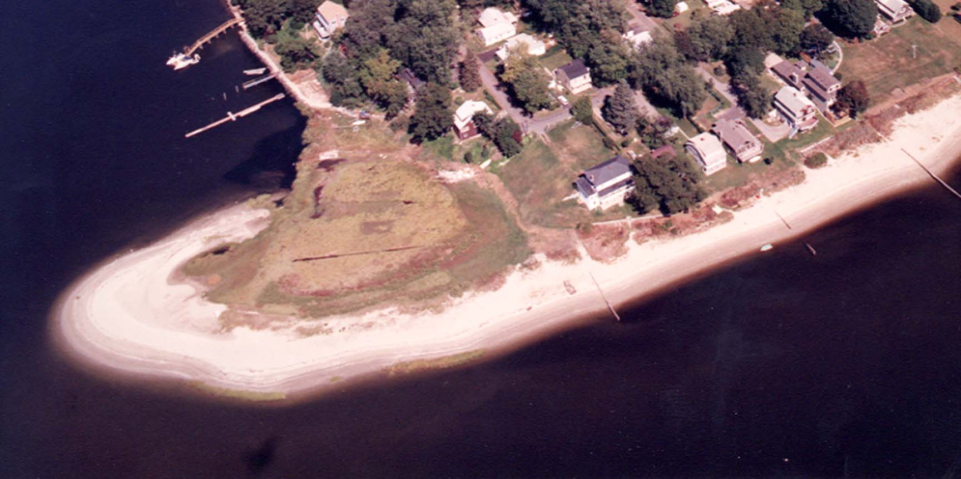
Cedar Tree Point Association – Founded 1924 - Visit our website: www.cedartreepoint.org
Welcome to Cedar Tree Point Association's Social Events Calendar for 2006! Everyone is welcome to join us in celebrating our community at these events. Mark your calendars now and don’t miss these fun events! Have a question? You can reach Dave Pickering, President at 737-7769!

Tuesday, CTPA’s Spring Meeting – 7:30 PM
June 13th This year’s spring meeting, being held at the home of Andrea Souza, CTPA Treasurer, 26 Anthony Avenue, will focus on some fun and interesting topics including:
- The history of Greenwich Bay, Apponaug and our beach right here on Cedar Tree Point! Don D’ Amato, local historian, will give an interesting talk and answer your questions about the fascinating history about our own back yard! If on your strolls at the beach, you have discovered Indian arrow heads and other artifacts bring them to the meeting and learn about their history!
Saturday,
July 15th Beach Cookout and FIREWORKS! Come and enjoy hotdogs and hamburgers with friends and neighbors, followed by a campfire, music, marshmallows and “S’mores”! The evening will conclude with an exciting professional FIREWORKS display!

Saturday, Annual CTPA New England Clam Bake The annual CTPA Clam Bake
September 9th is always a GREAT time! All the fixing’s including lobsters, clams, corn-on-the-cob, potatoes, fish, etc. Followed by a campfire, music & S’mores!
Wednesday,
October 4th Annual CTPA Fall Meeting CTPA's semi-annual association meeting.
Location TBD. Starting time is 7:30 PM. Location TBD.
“Anytime
Events” Campfires & S’mores throughout this year’s season! We will also be hosting some of our famous “CTP Campfires on the Point”! Watch for notices or the “spur of the moment” smoke & fire on the point, grab your lawn chairs and join your friends for an fun evening around a warm campfire for fun music, toasting marshmallow’s and making s’mores!

Special Note: CTPA annual membership dues have remained at $20 per family per year, for many, many years. The CTPA Board does this to insure that every family can afford to belong! Please contact Andrea Souza, Treasurer at asouza4@netzero.net or 401-738-6343 with any membership questions. You may mail your dues, payable to Cedar Tree Point Association, to Andrea at, 26 Anthony Avenue, Warwick, RI 02886.

