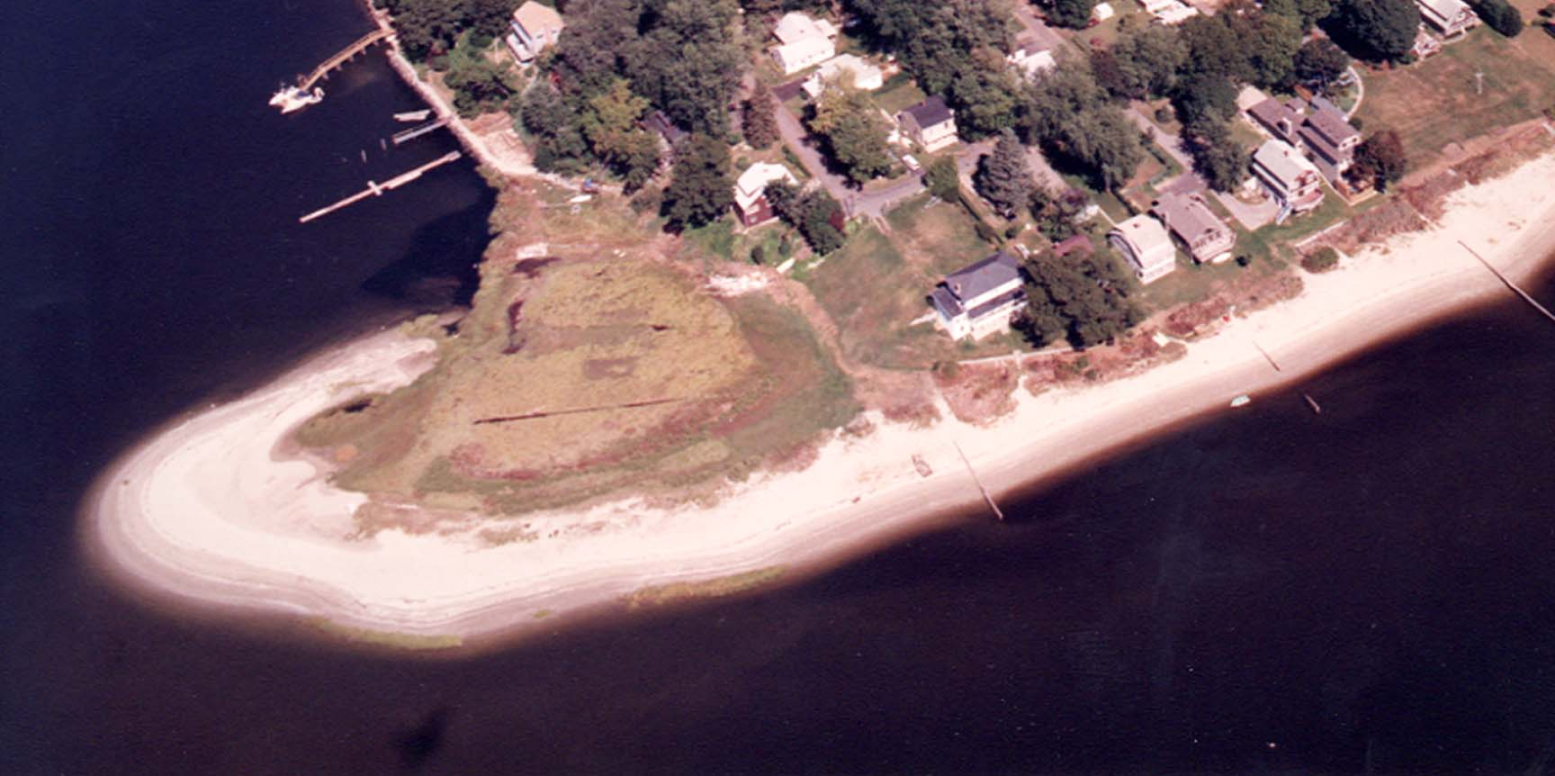
Cedar Tree Point Association – Founded 1924 - Visit our website: www.cedartreepoint.org

2010 Spring Meeting

April 15th - 7:00 PM
293 Grand View Drive

Dear Friends,

Recently I have been approached by several of the new families moving into the area, many with children, as well as long time association members, seeking to revive the association! We are so fortunate to live in one of the most beautiful parts of the world, where we can enjoy the beauty of the beach and waters of Greenwich Bay, and most importantly, the friendship and fellowship that we all enjoy in getting together!

The CTPA was founded in 1924, on the principles of bringing families together to have fun and to address community issues. The association has sponsored many social events from 4th of July Celebrations, Lobster / Clam Bake Dinners on the Point, Community Yard Sales, May Breakfast’s, Restoration of the Cemetery, to Christmas, New Year’s and Halloween Parties for the Kids and many other social events.

Over the past few years however, the Cedar Tree Point Association has been dormant, with all of our lives becoming busier than they ever have been in the 86 years of its existence. New association signs are under development and will be in place soon!

My wife Leann along with CTPA Board Members Andrea Souza and Lincoln Ross, invite you to visit our home for refreshments and a meeting to get your ideas and interest in the association as we develop a calendar of events for 2010. Everyone is welcome!

As always, I welcome your thoughts, ideas and comments and can be reached at 401-742-5039 or my email address: ifcndpickering@aol.com.

Warmest regards to you all,

Dave Pickering

President

