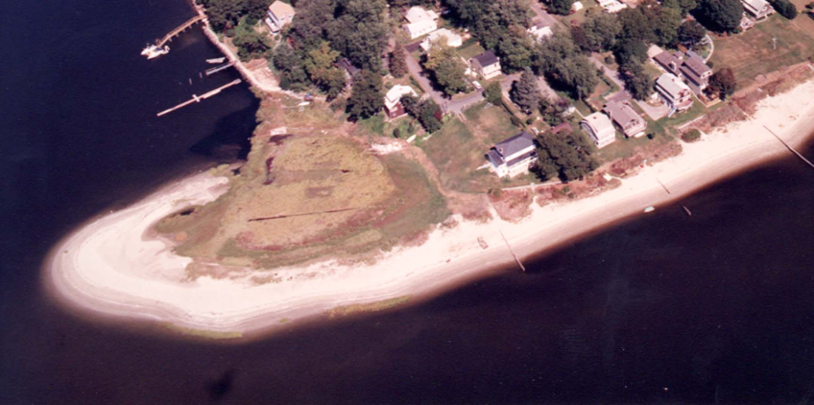
Cedar Tree Point Association – Founded 1924 - Visit our website: www.cedartreepoint.org

2nd Meeting

April 28th- 7:00 PM
293 Grand View Drive
(Dave & Leann Pickering’s home)
Dear Friends,

The large turn out at our first meeting on the 15th, with more than 25 Cedar Tree Point residents in attendance and the great interest in the association was exciting to see!

Several community impact topics were discussed including; a potential beach replenishment project, community neighborhood watch, new CTPA signs, the establishment of a “City Relations Committee”, notification of Right of Ways, Beach Clean-Up, Keeping Cedar Tree Point properties clean and attractive and others.

Social topics were also a big part of our meeting including the establishment of a date for a Cedar Tree Point Association / Cedar Tree Point Reunion Cookout, scheduled for Saturday, July 10th, with a rain date of Sunday, July 11th. This would be open to any and all current or former Cedar Tree Point residents who would love to get together, reminisce fond memories, enjoy a cookout and Campfire that evening right on the Point! Other holiday events were also discussed, specifically ones that would include and be focused on the growing number of children at Cedar Tree.

At our next meeting we will further discuss these and other topics, create committee chairs and their committee members, vote for officers for the association and begin the planning of dates for additional social events and strategies for community impact issues and topics.

It was really great to see so many new faces as well as long time friends! We encourage those of you who were not able to make the first meeting, to please join us as we all have the common goal of enjoying the beautiful community and beach that we are all privileged to be part of our lives! An email will be going out shortly to everyone who attended on the 15th!

As always, I welcome your thoughts, ideas and comments and can be reached at 401-742-5039 or my email address: ifcndpickering@aol.com.

Warmest regards to you all,

Dave Pickering

President

