Celebrating CTPA’s 80th Year!!!
Dear Friends,

This year we celebrate our 80th year as an organization! The CTPA was founded on the principles of bringing families together to have fun and to address community issues and opportunities together! We continue to strive to keep those principles!

We are so fortunate to live in one of the most beautiful parts of the world, where we can enjoy the beauty of the beach and waters of Greenwich Bay, and most importantly, the friendship and fellowship that we enjoy together! What is particularly rewarding to me personally is the number of children who continue to join their parents and friends at all of these exciting and enjoyable events. To see the excitement of the kids (and I will admit to falling into this category myself on occasion!) having fun making s’mores around the campfires, enjoying the music, playing horseshoes or badminton on the beach or by our picnic table, is for me, what it’s really all about.

Last year was one of the most successful years the Cedar Tree Point Association has ever experienced! I would like to personally thank all of the officers and members who worked so hard together as a team to make this all possible. Lobsters, steamers and the fixin’s for 40 people is quite a challenge when delivered as a sit down meal with table and chairs at the end of the point on the beach! Thank you one and all for this amazing effort! If you missed it last year, don’t let this exciting event pass you by again!

While all these functions are enjoyed by many it is important to understand that any successful organization requires among other things, the resources of volunteers and funding. We encourage any family or family member, who receives this flyer to enjoy the fun of volunteering at any of the CTPA functions. Every family and family member is welcome to become a member of the CTPA, and any effort to volunteer, regardless of how small it may seem, is not only greatly appreciated, but is essential to our continued success!

I am pleased to announce that the CTPA has an official website! The web address is www.cedartreepoint.org While several people contributed to this wonderful project, it is through the great effort and creative skills of Carol Fritz that this project came together. Carol’s efforts now give us, as an association, the ability to communicate directly with our membership in a very timely fashion. The site is also a great resource to keep up to date on the following:

- The Greenwich Bay Special Area Management Plan
- The Greenwich Bay Fishkill – 2003 Causes and Impacts
- Greenwich Bay Tide Charts
- Local Cedar Tree Point weather, CTPA Events and many other items of interest

I would also encourage you to visit the site and to click onto Mike Hoglund’s name, under the “Officers of the Association” and send Mike your email address that you would like us to use to contact you, along with your current telephone and/or cell numbers and address. This will give us the ability to send out information on a moments notice and keep everyone informed as to current events and important community information as it develops.

I am also pleased to report that the CTPA is also involved in local community efforts, one in particular which is on the minds of us all, is the Greenwich Bay Special Area Management Plan (SAMP). Carol Fritz, representing the CTPA, has invested well over 100 hours of her own personal time to attend meetings and communicate with this and other organizations. Carol is a wealth of information, and is kind enough to share it with everyone. My personal thanks to you Carol, for your efforts on both the website and the SAMP project.

We are pleased to report, that the dues of the Cedar Tree Point Association have remained at $20 per family per year, for many, many years. The CTPA board has made this decision, to ensure that every family can afford to belong to this wonderful community organization. You can contact Mike Hoglund our treasurer via the CTPA website or at 401-738-8488 with membership questions or at 22 Ferncliff Avenue, Warwick, RI 02886 for payment of dues. Thank you for supporting your CTPA!

As always, I welcome your thoughts, ideas and comments. I can be reached at 401-737-7769 or ifcndpickering@aol.com

Warmest regards to you all,

Dave Pickering

President

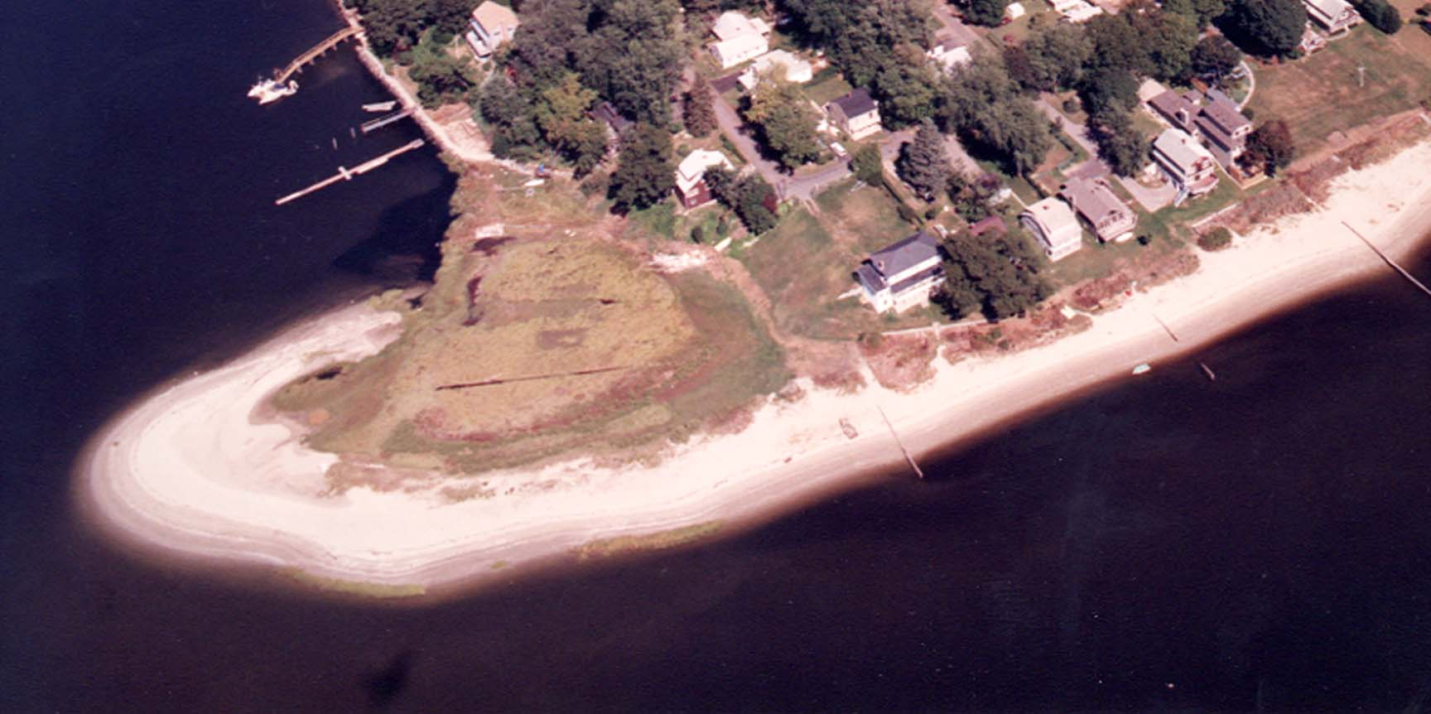
Cedar Tree Point Association – Founded 1924 - Visit our NEW Website: www.cedartreepoint.org

2004 Cedar Tree Point Social Calendar!
Welcome to Cedar Tree Point Association's Social Events Calendar for 2004! All members, families and guests are welcome to join us in celebrating our community at these events. Last year was an exceptionally successful year for CTPA. All of the events were well attended with great fun and fellowship had by all! Our first and now to be “annual” Lobster Bake had more than 40 people enjoying lobsters, steamers and all the fixins’ right on the beach at the point!
Mark your calendar now and don’t miss the fun this year!

Saturday,
April 10th: Annual CTP Spring Meeting & Party To be held at Mike and Ann Hoglund's house. Recommended attire for this "costume optional" party is to wear casual summer attire in anticipation of a warm and pleasant spring/summer/fall in 2004! The party will start at 7:00 PM and will be preceded by the semi-annual, (spring), CTPA business meeting from 6:30 - 7:00 PM. As we always do for these semi-annual meetings and parties, please, if you can, bring Hors d’oeuvres or desert to share!
Saturday,
May 22nd: CTPA Annual Beach Cleanup All hands on deck from 9:00 AM - 11:00 AM for this event, which will tentatively be preceded by breakfast. Please contact us if you are interested in hosting or assisting in this meeting!
Friday,
June 25th: Bonfire/Campfire An early evening bonfire/campfire on the beach followed by s'mores for parents, kids, and the young-at-heart members! This event will start at 7:00 PM. Soda, water and music will be provided!
Saturday,
July 17th: Annual Beach Cookout Don’t miss our annual cookout on the beach featuring summer picnic food, e.g., hot dogs/ hamburgers/chips/salads, accompanied by swimming/socializing with members of CTPA. This event will start at 5:00 PM as high tide for that day is scheduled for around 9:00 PM. A bonfire/campfire with s’mores & music will follow!
Saturday,
Aug. 28th: Annual Steak Fry CTPA's annual steak fry will start at 5:30 PM and will be held at Sharon Folco's house.
Saturday,
Sept. 18th: Annual CTPA Lobster Bake The second annual CTPA Lobster Bake on the beach. Starting time is 5:00 PM. Extra cooks and kitchens are especially welcome!
Friday,
Oct. 22nd: Annual CTPA Fall Meeting CTPA's semi-annual association meeting. Location TBD. Starting time is 7:00 PM.

